Tutorial – 9.1

**Aim:** The Distance between two cities (in km) is input through keyboard. Write a shell

script to convert and print distance in meters, feet, inches and centimeter.

**Code:**echo "Enter distance (in km) : "

read km

meter=`echo $km \* 1000 | bc`

feet=`echo $meter \* 3.2808 | bc`

inches=`echo $feet \* 12 | bc`

cm=`echo $feet \* 30.48 | bc`

echo "Total meter is : $meter "

echo "Total feet is : $feet "

echo "Total inches is : $inches "

echo "Total centimeters : $cm "

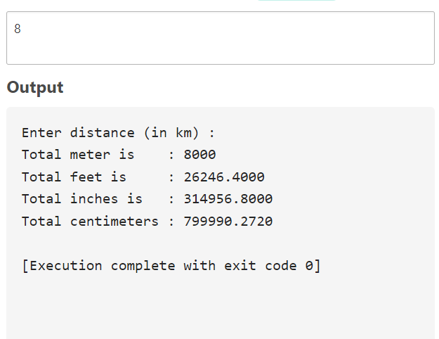**Output:**